LAB 3:

Simulation of network devices using cisco packet tracer

Objectives:

- Developing a foundational understanding of computer networking through virtual modeling.

- To study the working principles of network devices such as hub, switch, bridge, router, and repeater.

- To observe data transmission and packet flow between different network devices.

Theory:

Cisco Packet Tracer serves as a comprehensive visualization tool for designing and testing virtual network architectures. It allows users to simulate real-world hardware—such as routers and end devices—to practice configuration and troubleshooting in a risk-free environment. Packet Tracer helps in understanding networking concepts, observing packet flow, and practicing configuration and troubleshooting, making it an effective learning tool for computer network studies.
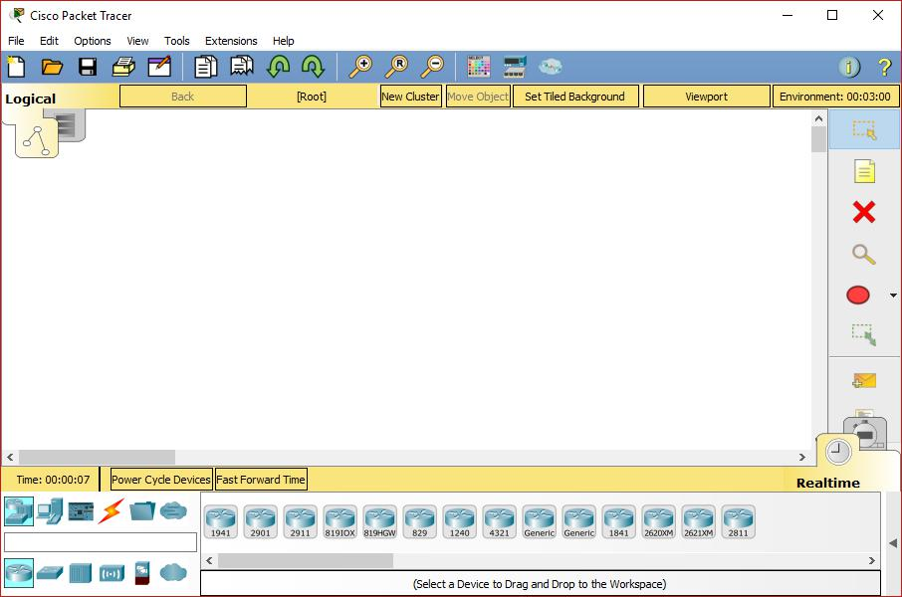

Hub:

A hub is a basic networking device used to connect multiple computers in a network. It works by receiving data from one device and sending it to all other connected devices, without checking who the actual receiver is. Because of this, data collisions can occur, making hubs less efficient.
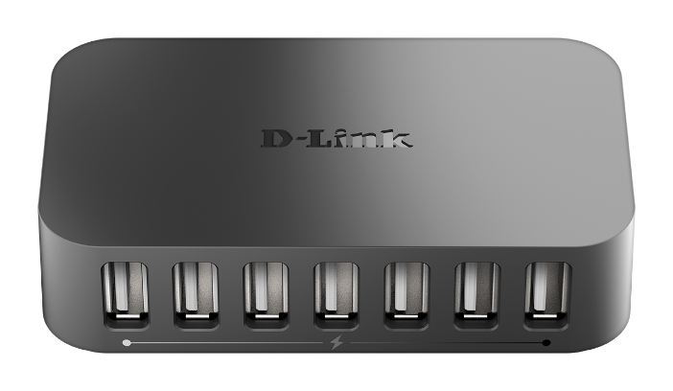
Switch:

A switch is an advanced alternative to a hub that connects multiple network devices. Unlike a hub, it utilizes MAC addresses to deliver data specifically to the targeted device. This method minimizes traffic and collisions, making switches the standard for high-performance Local Area Networks (LANs).
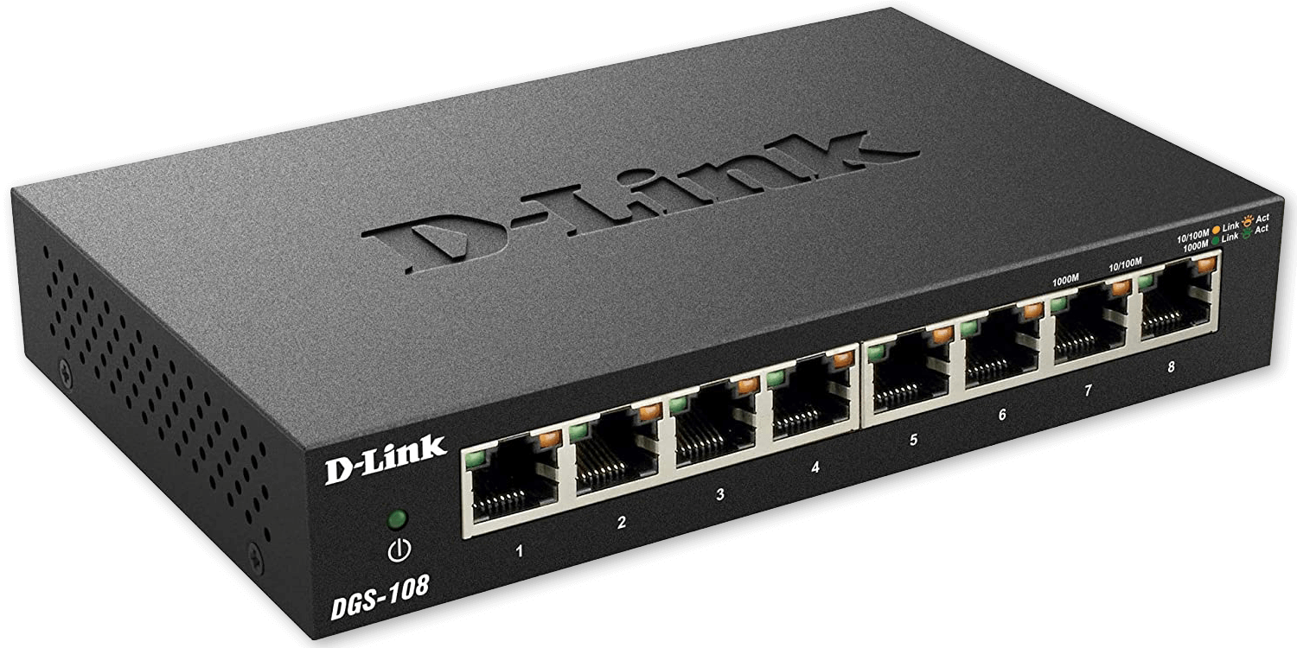
Bridge:

A bridge is a device designed to partition a large network into smaller, manageable segments. It reduces congestion by filtering traffic and only allowing necessary data to cross between segments.
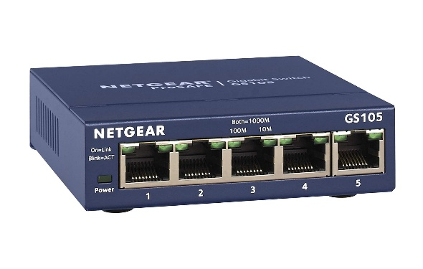

Router:

A router is a device that connects different networks together. It is mainly used to route data packets from one network to another using IP addresses. Routers choose the best path for data transmission and help in connecting local networks to the internet.
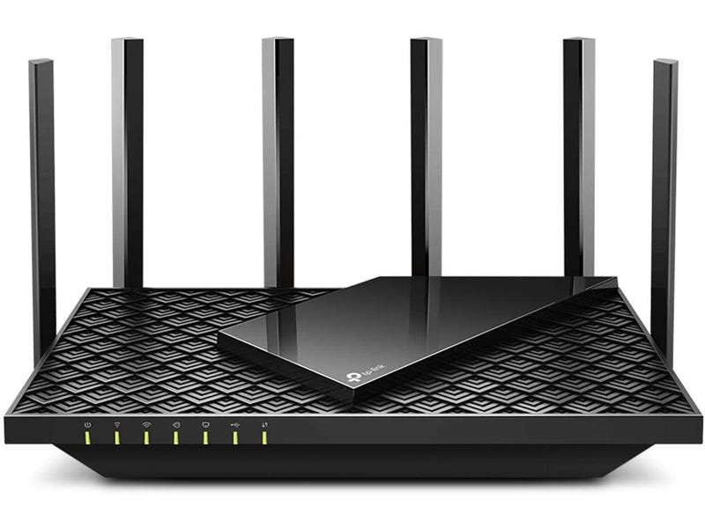

Repeater:

A repeater is used to extend the distance of a network. It works by receiving weak signals and regenerating them before sending them forward. Repeaters do not process or filter data; they only strengthen signals. They are useful when network cables need to cover long distances.
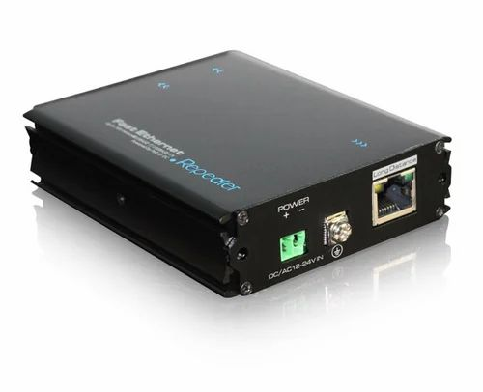

OBSERVATION:

Hub:

Hub-PT Hub0

PC Name | IP Address
PC-PT PC0 | 192.168.1.1
PC-PT PC1 | 192.168.1.2
PC-PT PC2 | 192.168.1.3
PC-PT PC3 | 192.168.1.4
PC-PT PC4 | 192.168.1.5
PC-PT PC5 | 192.168.1.6
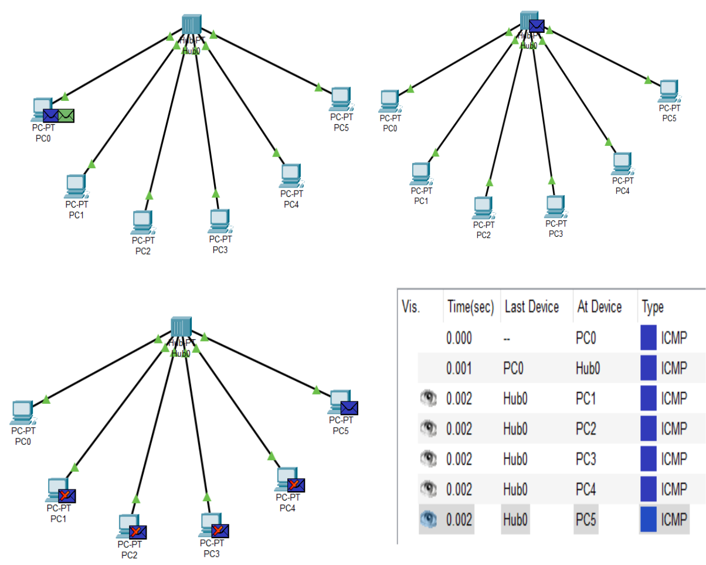

In this experiment, the hub (Hub0) was used to connect multiple devices in a single network. It was observed that when data was sent from one device, the hub broadcasted the data to all connected devices. This resulted in unnecessary traffic and chances of collision. The simulation helped in understanding why hubs are inefficient and are rarely used in modern networks.

Switch:

2960-24TT Switch3

PC Name | IP Address
PC-PT PC13 | 192.168.1.1
PC-PT PC14 | 192.168.1.2
PC-PT PC15 | 192.168.1.3
PC-PT PC16 | 192.168.1.4
PC-PT PC17 | 192.168.1.5
PC-PT PC18 | 192.168.1.6
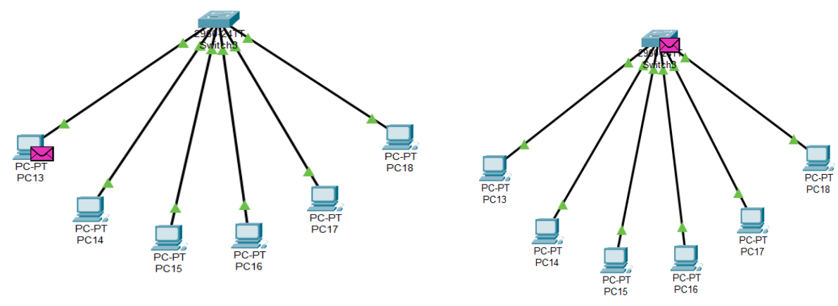

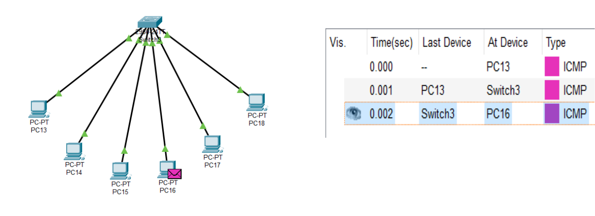

The switch (Switch3) demonstrated a marked improvement over the hub. Data was directed only to the specific destination address rather than being broadcasted to the entire network. This process, powered by MAC address recognition, proved that switches offer a more reliable and faster communication method for LAN environments.

Bridge :

Bridge: Bridge-PT Bridge0

Switch: 2960-24TT Switch4

2960-24TT Switch5

PC Name | IP Address
PC-PT PC19 | 192.168.1.1
PC-PT PC20 | 192.168.1.2
PC-PT PC21 | 192.168.1.3
PC-PT PC22 | 192.168.1.4
PC-PT PC23 | 192.168.1.5
PC-PT PC24 | 192.168.1.6

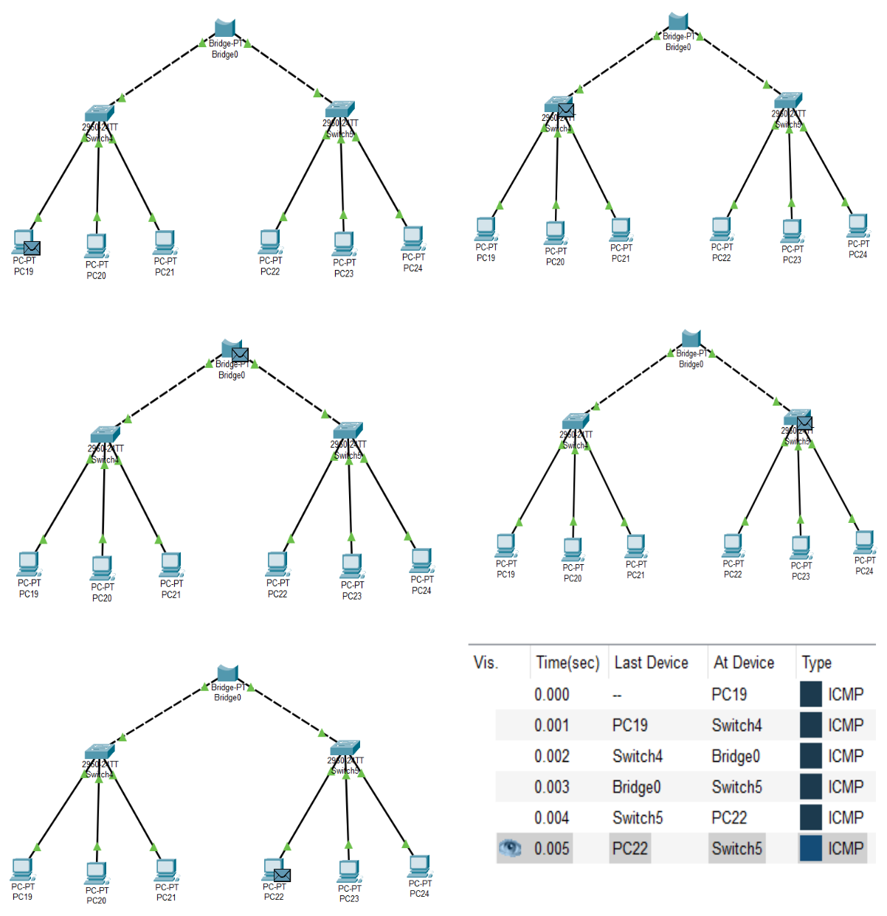

By using a bridge (Bridge0) to separate the network, it was observed that the device effectively filtered traffic. Only the data intended for a different segment was permitted to pass, which successfully lowered overall network congestion and improved efficiency.
Router:
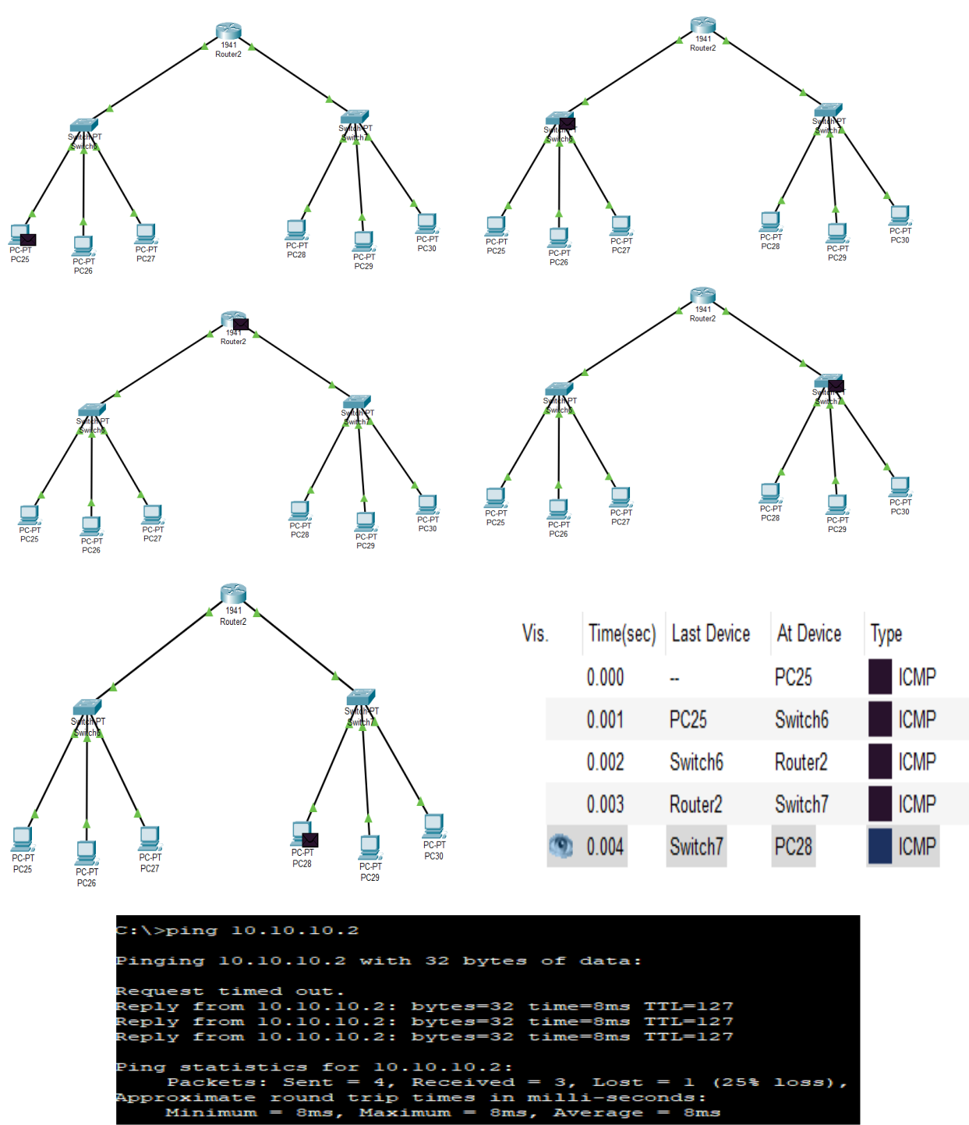

Switch: 2960-24TT Switch4

2960-24TT Switch5

Router: 1941 Router2 | IP Address
GigabitEthernet0/0 | 192.168.1.1
GigabitEthernet0/1 | 10.10.10.1

PC Name | IP Address
PC-PT PC25 | 192.168.1.2
PC-PT PC26 | 192.168.1.3
PC-PT PC27 | 192.168.1.4
PC-PT PC28 | 10.10.10.2
PC-PT PC29 | 10.10.10.3
PC-PT PC30 | 10.10.10.4

The router (Router2) was essential for bridging communication between two distinct IP subnets (192.168.1.x and 10.10.10.x). The simulation confirmed that the router could accurately direct packets based on IP addresses. This highlighted the router's role in inter-network connectivity and its necessity for internet access.

Repeater :

Repeater: Repeater-PT Repeater0

Switch: 2960-24TT Switch3

2960-24TT Switch4

PC Name | IP Address
PC-PT PC0 | 192.168.1.1
PC-PT PC1 | 192.168.1.2
PC-PT PC2 | 192.168.1.3
PC-PT PC3 | 192.168.1.4
PC-PT PC4 | 192.168.1.5
PC-PT PC5 | 192.168.1.6

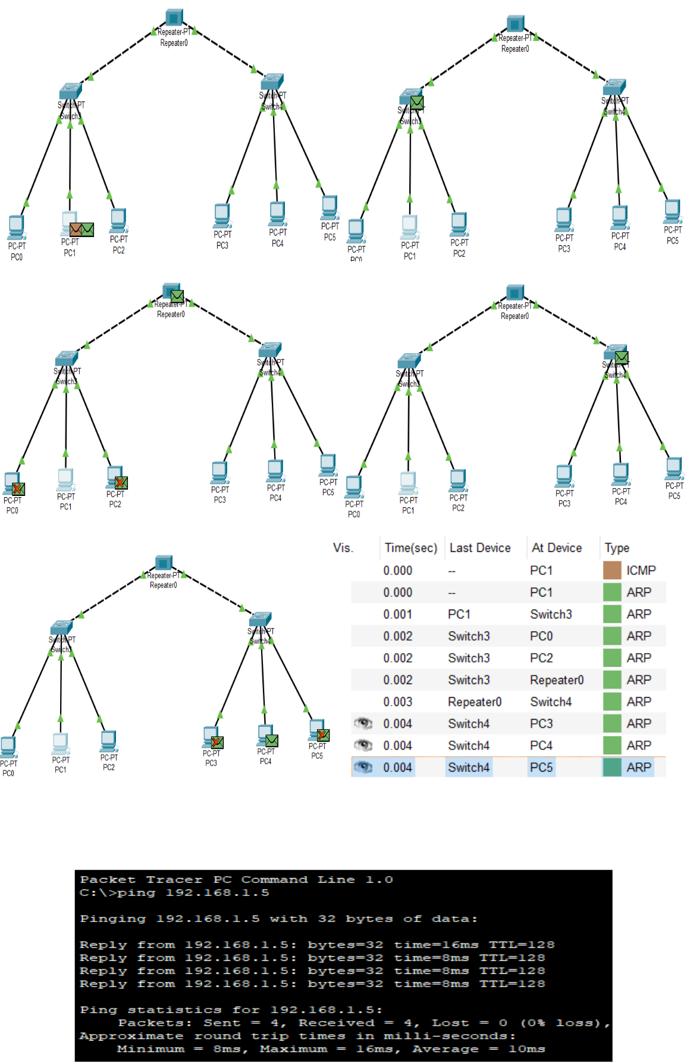

The repeater (Repeater0) was implemented to extend the reach of the network signal. We observed that it regenerated weak signals, allowing data to traverse longer distances without degrading. Because the repeater only boosts the signal without modifying the data, it remains a vital tool for maintaining signal integrity over large physical areas.

Discussion and Conclusion:

This lab session was successfully finalized using Cisco Packet Tracer to model a variety of network hardware. The exercise provided a practical look at the internal workings of hubs, switches, bridges, routers, and repeaters without the constraints of physical hardware. Ultimately, the lab emphasized the importance of selecting the correct hardware based on specific network goals and significantly improved our skills in network design and analysis.

